University of Dublin



Trinity College

The Reporting of Concussion in Sport

Daniel Owen

B.A.(Mod) Computer Science and Business

Final Year Project, April 2017

Supervisor: Mary Sharp

School of Computer Science and Statistics

O’Reilly Institute, Trinity College, Dublin 2, Ireland

Declarations

I hereby declare that this project is entirely my work and that it has not been submitted as an exercise for this or any other university.

____________________ ________________________

Signed Date

Acknowledgements

First of all, I would like to thank my supervisor Professor Mary Sharp for her never-ending support and guidance throughout the year and especially for keeping me on track during this project. It is very much appreciated and without it, this project would not be where it is today.

Secondly, I would like to express my sincere gratitude to my family, classmates, and friends for their help and encouragement during my four years in Trinity.

Finally, I would like to thank the referees who participated in my interviews to find out more information about how concussions are dealt with and reported.

Abstract

The objective of this project was to create a tool by which referees can monitor players with concussions. This is to make sure that somebody who has received a concussion in the previous number of weeks cannot play before they have completed the IRFU’s Gradual Return to Play (GRTP) Protocol. This report sets out to give the path taken by the author to build ‘Concussion Log’, the website tool.

Within the website, users are able to sign up and login, insert new records, edit existing submissions, view records, search the database, and delete records they have input. The site can be found at [concussionlog.net16.net](http://concussionlog.net16.net/). Please feel free to sign up and look around.

1 Introduction 1

1.1 Aims 1

1.2 Personal Motivation 2

1.3 Reader’s Guide 3

2 Background 5

2.1 Effects of Concussion 5

2.2 Accessibility 6

2.3 Existing Methods of Reporting 8

2.3.1 Professional Rugby 8

2.3.2 Domestic Rugby 8

2.4 Chapter Conclusion 9

3 Requirements Analysis & Design 10

3.1 Design Research 10

3.2 Primary & Secondary Research 10

3.2.1 Primary 10

3.2.2 Secondary 10

3.3 Requirements 11

3.3.1 Functional Requirements 11

3.3.2 Non-functional Requirements 12

3.4 Technical Approach 13

3.5 Multitier Architecture 14

3.6 SDLC Model 15

3.7 User Interface 16

3.7.1 Mock-ups 17

3.7.2 Reality 17

3.8 Chapter Conclusion 18

4 Implementation 19

4.1 Technologies Used 19

4.1.1 MAMP 19

4.1.2 000webhost.com & phpMyAdmin 19

4.1.3 GitHub 20

4.1.4 Sublime Text 21

4.2 Languages Used 21

4.2.1 HTML 21

4.2.2 CSS 21

4.2.3 JavaScript 21

4.2.4 PHP 21

4.2.5 MySQL 22

4.3 Implementing the _______ Page(s) 22

4.3.1 Landing 22

4.3.2 Registration & Login 22

4.3.3 View Records & Search 23

4.3.4 Insert & Update Records 24

4.4 Chapter Conclusion 26

5 Evaluation 27

5.1 Testing 27

5.2 The Grand Critique 27

5.3 Ethical Considerations 29

5.4 Chapter Conclusion 30

6 Conclusion 31

6.1 Issues 31

6.2 Future Work 32

6.2.1 Research Partner 32

6.2.2 Statistical Element 33

6.2.3 Increased Search Functionality 34

6.2.4 System Usability Scale (SUS) 34

6.3 Conclusion 35

Appendices 36

Ethics Approval Documents 39

References 43

Tutorials Used 45

Figure 1: A brain with CTE compared with a normal brain 6

Figure 2: Landing Page Screenshot 7

Figure 3: Law 3.10 (World Rugby, 2017) 9

Figure 4: GRTP Protocol (IRFU, 2013) 12

Figure 5: Two-Tier Architecture Representation 14

Figure 6: Registration Snippet 15

Figure 7: Incremental-Iterative Hybrid 16

Figure 8: Landing Page Mock-up 17

Figure 9: Landing Page UI 17

Figure 10: Screenshot of phpMyAdmin UI 20

Figure 11: Git Bash 20

Figure 12: Email Address Match 23

Figure 13: Login Error 23

Figure 14: Edit/Delete 24

Figure 15: Update Record 25

Figure 16: Datepicker 25

Figure 17: Local Server Connect 28

Figure 18: 000webhost Server Connect 28

Figure 19: Popup Notification 29

Figure 20: Date Difference Function Version 5.3+ (PHP, 2009) 31

Figure 21: Concussion Log Date Difference 32

Figure 22: Statistical Element Mock-up 33

Figure 23: Number of Concussions per Month 34

# 1 Introduction

Concussion is one of the most serious injuries in sport. It is an injury to the brain which results in a loss of normal brain function (American Association of Neurological Surgeons, 2017). In the last number of years, it has come to the fore of the media. What makes concussions so alarming to the public, and the wider rugby community, is the effect that it can have on an individual in the short term and the newly established links between concussions and degenerative brain diseases like chronic traumatic encephalopathy (CTE) (Omalu, et al., 2005). This disease has been found in the brains of a number of American football players who died prematurely. Each of the players found to have this disease dealt with a huge number of concussive or sub-concussive blows to the head throughout their playing career. What is frightening about this fact is that American football players (0.2 per 1000 player hours), in general, have a lower rate of reported concussions than professional rugby players (3.9 per 1000 player hours) (England Rugby, 2016).

Another worrying fact about the reporting of concussion in rugby is the underreporting of mild traumatic brain injuries (MTBI) by players. Per a study of Irish U20 rugby players, the author found that 44% of the players surveyed who had received a concussion over the previous year, had failed to report it (Baker, et al., 2012). Much of this is due to the fact that players don’t want to be seen as weak or they don’t want to let their teammates down by going off with an injury.

Concussion Log is a tool which sets out to deal with this second problem. It allows referees to log onto the system and input the details of a concussion that occurred during a match they officiated. Along with this, the tool would help referees of future matches to see if a player has completed the Gradual Return to Play (GRTP) Protocol which sets out a period of time a player must take to recover depending on their age. During this time period, a player is not allowed to return to the field of play.

This report examines what exactly it took to bring the project from the Ideation Phase through to its current iteration of a live website which allows a user to sign up, view records, insert records for matches they have officiated, and search the database.

## Aims

When the author started the project his aim was to get a better understanding of how exactly concussion is reported in rugby and to establish a platform by which referees can play their part in making sure that players who have received a concussion don't come back to play before they have successfully completed all of the necessary return to play protocols as outlined by the IRFU’s GRTP guidelines which are put in place for the safety of all those who play the sport in Ireland, at both underage and senior levels.

The website goes some way in helping referees with the aforementioned aims. It does this with the help of the following:

* A way to register and login to the system.
* A database to store the names of player who have received a concussion and the date on which the concussion happened.
* The ability to insert new submissions to the database when a user is logged in to their account.
* Allows referees to search for specific attributes e.g. player name, club or date, using the search function.
* Referees are allowed to edit and delete rows that they have submitted.
* Gives quick and easy access to necessary safety documentation for both parents and referees.

## Personal Motivation

The author has a significant interest in this topic since he is an avid rugby supporter and plays for his local club at a senior level. Over the years he has played, he has received several concussions, some of which affected his ability to continue with his normal life in the week after the injury. This was seen not only in the author but also in a number of other rugby playing friends.

The actions usually taken when a concussion was received was to take a couple of weeks away from full contact rugby before returning. Most of the time this isn't a satisfactory solution as some concussions are much worse than others and the amount of time taken to recover can vary greatly. In the last number of years, the concussion is a huge sticking point for the IRFU and for other country’s governing bodies and for World Rugby in general.

## Reader’s Guide

**Chapter 2: Background**

This chapter looks at the developer’s decision to use a website design for his project rather than a mobile phone application. It also looks at how concussions are currently assessed and reported at both a professional and a domestic level. It also looks at the devastating effects that concussions can have on individuals.

**Chapter 3: Design**

The Design Chapter examines how the developer approached the project from a technical point of view. Also in this chapter, the author looks at some of the research that went into design, both primary and secondary. This chapter looks at the database design, the first mock-ups of the user interface and the software development model used. It also gives the initial requirements that were gathered, which the developer felt were most important.

**Chapter 4: Implementation**

This chapter will give an overview of the technologies and software used to bring the website from the idea stage to its current iteration. It looks at HTML, CSS, PHP, MYSQL and JavaScript as standalone technologies and it examines phpMyAdmin, MAMP, Sublime Text, GitHub and 000webhost.com as facilitating software. It also analyses the implementation of different functions on each page.

**Chapter 5: Evaluation**

In this chapter, the author will critique the meeting of both functional and non-functional requirements for the project. The ethical considerations that need to be taken when using this website are looked at in this chapter.

**Chapter 6: Conclusion**

The concluding chapter gives a brief overview of how everything came together to make the project the success that it is. Along with this, it explores any issues the developer ran into over the course of the project. This chapter also explores, in depth, the author’s plans for the website in the future.

# Background

This chapter examines the author’s choice to make a website in place of a mobile application. It also looks at how concussions are currently dealt with at both a domestic and professional level and the effects concussion can have on an individual in both the short term and in the long term.

## Effects of Concussion

As previously stated, a concussion is an injury to the brain which results in the temporary loss of normal functionality within the brain (American Association of Neurological Surgeons, 2017). This in a formal medical definition is given as the immediate and transient alteration in brain function, including alteration of mental status and level of consciousness, resulting from machinal force or trauma (American Association of Neurological Surgeons, 2017).

All concussions should be taken seriously, even the effects of a sub-concussive blow can be felt days after. It can affect memory, balance, muscle coordination and speech among other vital actions. Some general symptoms that people who have received concussions can have are headaches, nausea, loss of consciousness and changes in mood. They can be seen in both children and adults but sometimes children have more difficulty displaying how they feel (Brainline.org, 2012). Many of these symptoms are evident straight away but some may show hours or even days later. A study conducted by Andrew Mayer at the Mind Research Network in New Mexico found that when the brains of 50 concussion patients were compared with the brains of the same number of healthy people, the concussion patients showed abnormalities four months’ post-concussion even though they felt better (Mayer, et al., 2013).

The effects of concussion can still be noticed even further along, years even. Per a study by Dr Maryse Lassonde on the long-term effects of concussion on athletes, she found that “there is abnormal brain wave activity for years after a concussion, as well as the partial wasting away of the motor pathways.” Both issues can lead to attention problems in both the short term and long term.

Chronic traumatic encephalopathy is a degenerative brain disease which is found in those who have received a severe blow or repeated blows to the head. It was first found in boxers, from which the term ‘punch drunk’ is derived. Initially, the disease was thought to have only been suffered by boxers but with Dr Bennet Omalu’s findings, further sports and high risk individuals such as military personnel were identified (Mooney, 2013). Below is an illustration of a brain with CTE compared with a normal healthy brain.

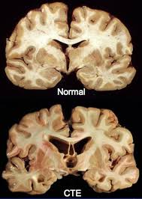

Figure : A brain with CTE compared with a normal brain

The first case of CTE in an amateur rugby player was documented as recently as 2015 in an Irish man (Stewart, et al., 2016). The disease was confirmed in an autopsy as the diagnosis was impossible when the patient was alive.

Within rugby, a huge amount of work is being undertaken regarding concussions and especially with the head injury assessment (HIA), a tool which was introduced to professional rugby in 2014. A considerable number of medical professionals who have worked with teams feel that the HIA doesn’t do enough to protect the player. Dr Cliff Beirne, a former Ireland team doctor believes that, “We know that if a player fails it (HIA), yes, they are concussed. But if they pass it, in my opinion, it doesn’t mean they are not concussed” (Whooley, 2017). This concern is also held by others such as Dr Barry O’Driscoll, an opponent of the HIA, who believes that World Rugby have “lost total control of concussion” (Glennon, 2017).

## Accessibility

The developer wanted his project to be accessible by anyone with an internet connection, be it wireless or otherwise, therefore he chose to develop it as a website as opposed to an application only accessible by an iOS or Android device.

As the website is live, it’s not restricted by the type of device used so anyone with a mobile, tablet or computer can access it. The decision to make this tool in website form is especially relevant to parents, players, or referees who may not have smartphones or who have smartphones but cannot access certain applications. The developer made sure that even when someone is using a mobile device, the websites provides all essential functionality such as registration, login, insert, view and search records in the database.

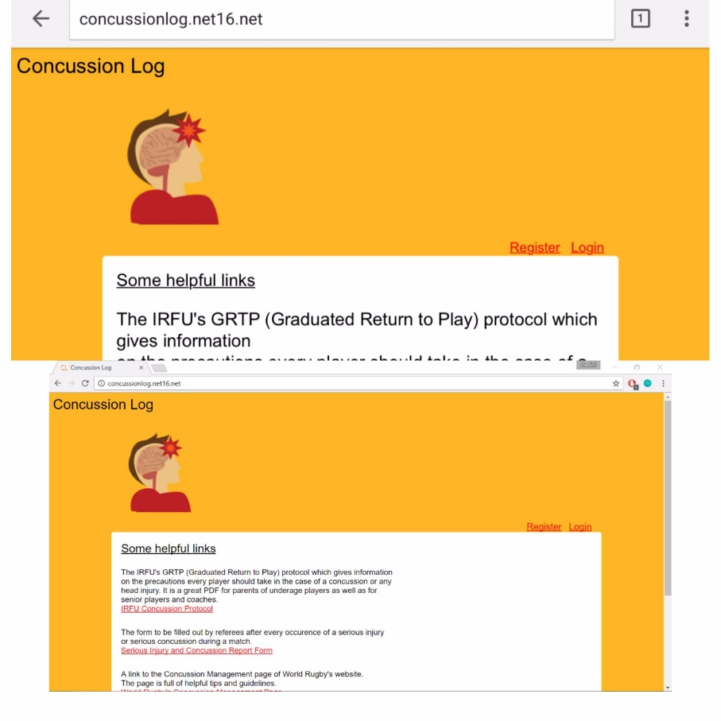

Figure : Landing Page Screenshot

The top image in *Figure 2* is the website as seen in a landscape view on an iPhone 6, while the bottom image is Concussion Log as seen on a laptop screen. On both a laptop screen and phone screen it is possible to zoom in making it easier for those with poor sight to read and understand content. The website follows several of the guidelines set out by W3C regarding web content accessibility guidelines (WCAG) 2.0 (W3C, 2008).

## Existing Methods of Reporting

Like all head injuries, concussions are serious and should be viewed as such by all parties involved. Nowadays, the response to a suspected concussion differs in both the domestic and professional game as there are no head injury assessments (HIA) allowed in domestic rugby. To find out what is exactly involved in both domestic and professional rugby, the author found that he would need to interview a referee. To do this, he would first need to seek approval from the Ethics Committee which is a requirement of Trinity Students. The author also used this interview as a way of finding out more of the end user needs (see Design Research for more information). The Application for Ethical Approval can be found in the appendices.

### Professional Rugby

In professional rugby, a HIA is administered to a player where a concussion is suspected. The player can leave the field of play for a maximum period of ten minutes. The HIA involves several cognitive, balance and memory tests to assist medics in helping to determine if a player has received a concussion. The number of players who returned to the pitch following a HIA dropped from 56% to 13% (Patricios, et al., 2017) following the introduction of HIAs to the professional game in 2014. Law 3.10 is invoked in professional rugby, mainly to order a player off the pitch for a HIA.

### Domestic Rugby

In domestic rugby where there is no HIA allowed, the duty of care falls on the referee, the player, and coaching staff. In the case where a coach refuses to remove a player from the pitch after the referee advises them to do so, the referee can invoke Law 3.10 which gives the referee the right to “order that player to leave the playing area” (World Rugby, 2017). If this law is invoked, the referee must report the name of the player along with, the name of the coaching staff and the club in his post-match report.

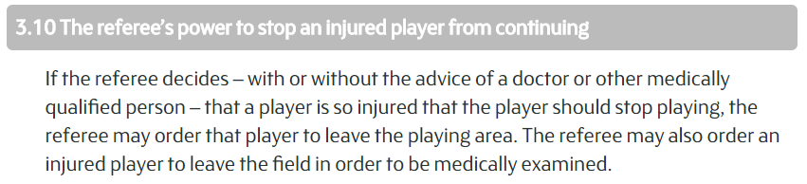

Figure : Law 3.10 (World Rugby, 2017)

Currently not all suspected concussions are reported by referees. This is because it would be impossible for them to diagnose a concussion themselves as they are not trained medical professionals. Even though it would be impossible for referees in the amateur game to diagnose a concussion, the author believes that a referee should report the incidence of any player leaving the field of play due to a blow to the head.

## 2.4 Chapter Conclusion

This chapter looked at the serious effects a single concussion can have on an individual in the short, medium and long term. It references several studies done by doctors with respect to concussion in athletes and looks and cites the first case of CTE in an amateur rugby player in Ireland. Secondly, it looked at why the developer chose to launch the system as a website rather than a mobile app and *Figure 2* shows what the Landing Page looks like on both an iPhone and a laptop screen as well as the following of accessibility guidelines set out by W3C. Finally, this chapter discusses exactly how a suspected concussion is dealt with at both an amateur and professional level. It goes through the HIA in depth and the invoking of Law 3.10.

# Requirements Analysis & Design

This chapter looks at the database design, the first mock-ups of the user interface and the software development model used. It also gives the initial requirements that were gathered, which the developer felt were most important.

## Design Research

When thinking about design and requirements for the system, the author had to first think about the type of users who would be using the website and of course what could be offered to them. From the start the system was being designed for referees, they would want a simple website where they could get from Point A to Point B with ease.

Future work will require some added functions for researchers which may lead to extra unnecessary functionality for normal users but this may also be avoided by having to separate types of account upon registration.

## Primary & Secondary Research

The developer undertook primary and secondary research to explore the best way of building his application. He did this in a couple of ways from interviewing referees to web research.

### Primary

When the author interviewed a referee, he learned a great deal about what exactly an end user would desire in this system. This way of design thinking is known as user-centered design as the development starts from an analysis of a user’s needs (Verganti, 2008). The developer felt this was the best approach to take as he could design the system around the needs of the user and not just what he thought was best. To find out how user-friendly the system is to an end user; the author will have to use the System Usability Scale (SUS). See Future Work for more details.

### Secondary

Further research was achieved through the use of the globally known resource, the internet. The ease of use and low cost makes the internet the best way to conduct secondary research today. Much of what the developer thought he would need to find through primary research was found on the internet when researching different topics making it an invaluable source of information. It helped clarify several questions such as, ‘What happens when someone suffers a suspected concussion in domestic rugby?’

## Requirements

A set of functional and non-functional requirements were gathered using the aims mentioned in Chapter 1.

### Functional Requirements

**Login System**

Necessary to make sure that there is a username stamp on every entry to show who is inputting the details of the concussion and to make sure that only the owner of an entry can change or delete it.

**Database Functionality**

The database will be used to store both the details of concussions and user profiles. It is necessary to link the new_record table in the database to the frontend for the user to see. This database must also be scalable and have the ability to handle many data inputs.

**Data Input**

A user should be able to input the information of a new concussion. The input form should be designed in a way that allows completion of the form by the user to be easy and efficient. This will ensure accurate completion of the form and ensure that a full record is added to the database.

**Eligibility**

Have a function which takes in the age of a player and the number of days since their concussion and assess whether they are eligible to play again or not. This function stems from the IRFU’s GRTP Protocol which states the amount of time a player is not allowed to play for depends on their age.

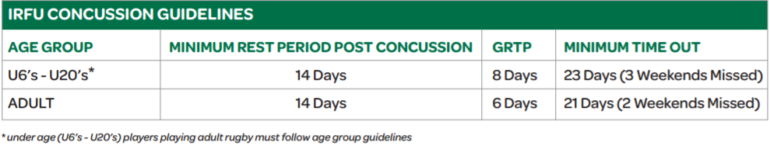

Figure : GRTP Protocol (IRFU, 2013)

**Search**

To decrease the amount of time and effort needed to use the website, a referee should be able to search for specific attributes e.g. player name or club, to make sure that all players are eligible to play a match.

### Non-functional Requirements

The author used a grouping mechanism for his non-functional requirements so that none would be missed. The four groups the author used are: Usability, Reliability, Performance, and Robustness.

**Usability:**

* The author wanted to make sure that the website was easy to navigate for the user with everything clearly labelled.
* Making sure that all critical functions are easy to use such as adding a concussion record as well as editing and deleting.

**Reliability:**

* Users should be able to trust the system built by the developer
* The system should run with as little downtime as possible. The author believes 000webhost provides good conditions for the hosting of both the website and database.

**Performance:**

* Website should run smoothly with fast response times no matter how much traffic is on it.

**Robustness:**

* The system should be able to handle all that is asked from it, even from the most inexperienced of users.

## Technical Approach

The developer felt the best way to make this project a reality was to develop a website which could be accessed and easily used on both a laptop/desktop and on a mobile/tablet. Using Sublime Text 3 as a text editor, the developer built the website using HTML, CSS, PHP and a small JavaScript script to take the date of concussion into the MySQL database which was made with the helping hand of phpMyAdmin, an open source tool written in PHP which handles the administration side of the MySQL database. MAMP was used initially by the developer when he was searching for a suitable hosting service to use. This tool saved countless hours when building the database in the early stages of the project.

The author made use of a number of learning tools such as Stack Overflow, w3schools.com, and Codecadamy. Much of what the author needed to know about PHP was found using the PHP documentation available online. Unfortunately, as the author only had PHP 5.2 available to him (000webhost haven’t updated their free servers to use newer versions of PHP), he couldn’t use some of the functions found in the newer versions of the scripting language.

## Multitier Architecture

There is currently a two-tier client architecture in use with Concussion Log. This was chosen over the three-tier alternative as there is very little data manipulation being done at present. The data manipulation that is being done though, is being done in the frontend.

In two-tier architecture, the direct communication takes place between the client and the server. Unlike three-tier architecture, there is no intermediary between them.

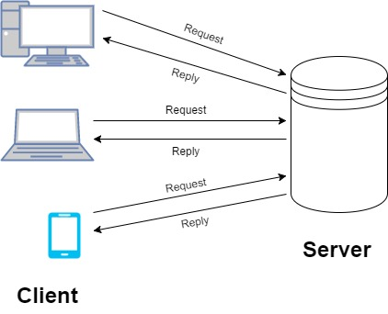

Figure : Two-Tier Architecture Representation

In the Client Tier, the main part is the user interface which is presented to the client on their screen. The user interface (UI) was made using HTML, CSS, and JavaScript. The Server Tier is made up of the MySQL database. All the information regarding users and concussions is stored in this database which is why the Server Tier is also sometimes known as the Data Tier. The technology which sends the requests and receives the reply is PHP. Below is a snippet from registration.php which registers a new user. It sends the new user’s details to the server which in turn inserts it into the database and returns that the user has been registered successfully.

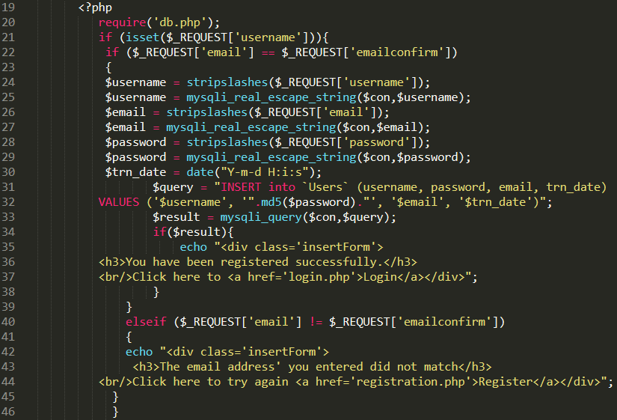

Figure : Registration Snippet

## SDLC Model

An iterative and incremental model hybrid was used over the course of this project. The developer felt this was the best option as it allowed him to implement new functional capabilities at each version of the website. It also that meant he could work around other college assignments and make small changes to his website when he had time.

The major requirements were defined at the beginning of the project which kept the developer on track throughout. In saying this, some extra functions were added as time went by to make the website more user-friendly and to provide more information for referees.

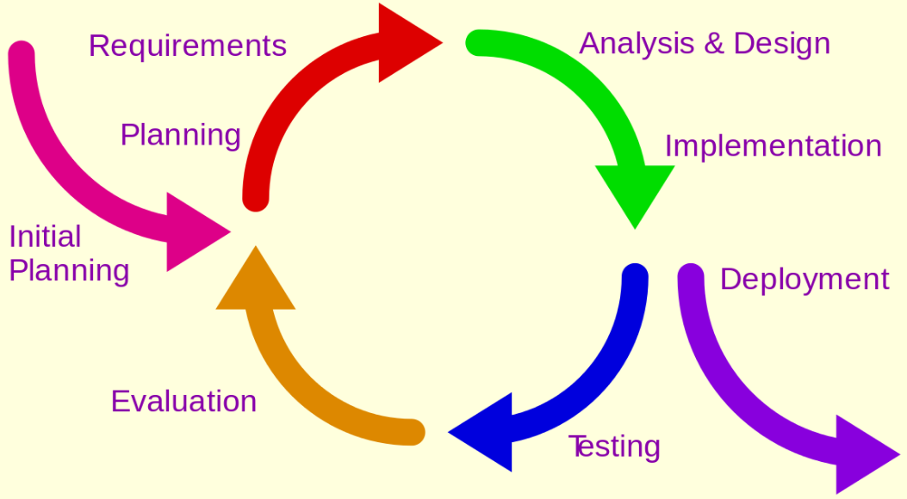

Figure : Incremental-Iterative Hybrid

The author found that this model was extremely helpful as there was a working system in place from an early stage in the development of the website. As opposed to the waterfall developmental model where value is only delivered once everything has been completed, this model gave value throughout and allowed backtracking. Along with having a working model quickly in the development lifecycle, debugging was mostly straightforward as it was clear to see if there were any problems as the changes made for each iteration were generally quite small.

## User Interface

The developer set out to produce a UI that was easy to use and helped direct the user all the way from registration to logout and everything in between. For this it needed to be extremely simple with no extraneous function or buttons. For the buttons that were there however, the developer wanted to make sure that they stood out to a user by using contrasting colours and underlined font. One screen mock-up and one screen capture can be found in this section; the rest can be found in the appendices.

### Mock-ups

The developer quickly sketched out a mock-up of each of the pages and how he thought they should look by the end of the project. *Figure 8* below is a mock-up of the landing page.

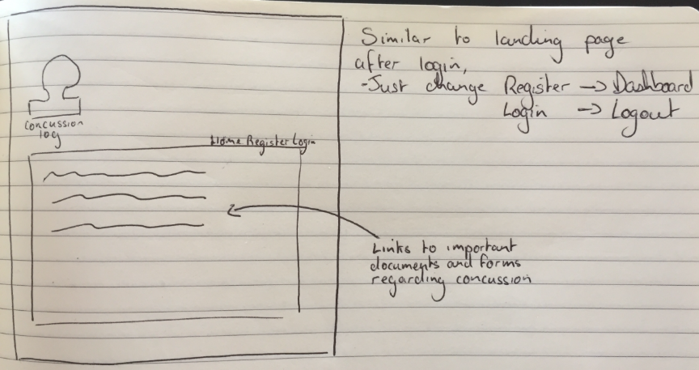

Figure : Landing Page Mock-up

### Reality

There is very little difference when the mock-up of the landing page is compared with the current iteration of the UI which can be seen below in *Figure 9.*

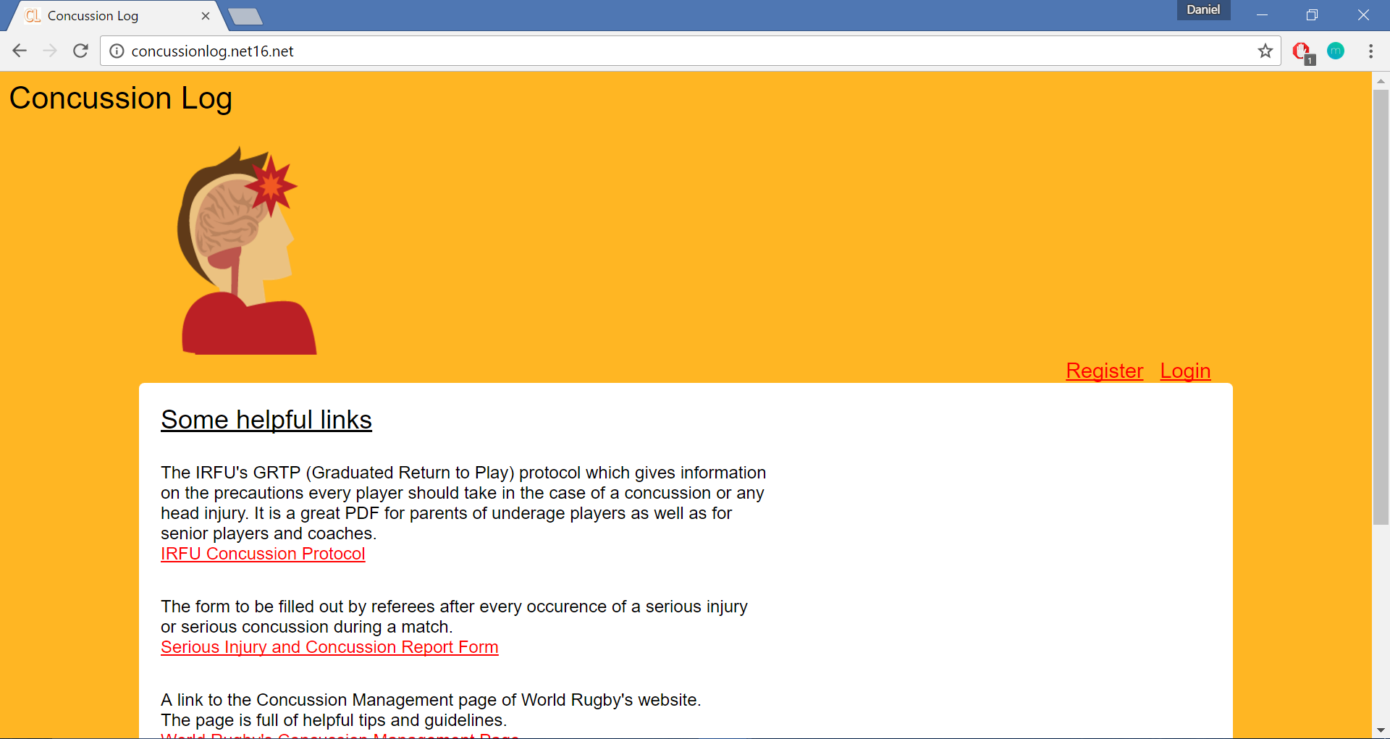

Figure : Landing Page UI

## Chapter Conclusion

This chapter looked at everything from the initial research to requirements gathering and the initial mock-ups of the UI. The research segment examines exactly what the author did to find out what an end user would want the website to look like as well as what functions were crucial. The requirements gathering phase is then investigated and the author talks about both functional and non-functional requirements he felt the system needed. The author then gives a quick overview on the technical approach and what software he used when building the website. From here, the author looks at the Client and Server Tier in the architecture of the system. The software development life cycle model chosen by the developer was an incremental-iterative hybrid and he examines the decision to use this model and the user interface towards the end of the chapter.

# Implementation

This chapter will give an overview of the technologies and languages used when developing the system. It also looks at each of them in more depth. Along with this, it examines how different parts of the system were developed.

## Technologies Used

### MAMP

MAMP installs a local server environment on your computer. It is a stack which provides the necessary elements of a web server. Within the stack, Apache acts as the web server, MySQL as the database, and PHP as the server side programming language. MAMP itself is designed for use on Mac operating systems but more recently, they released a version for Windows which is what the author used for the purpose of the project. The author used MAMP to test his PHP connections before he went on to find an online server which was necessary as he could only use MAMP on his own machine.

### 000webhost.com & phpMyAdmin

For the system environment to be brought from the author’s laptop to a live working model, the author would need an online host with similar capabilities to what MAMP could offer him. He felt that 000webhost offered him the best free service. He was also familiar with the workings of this service as he had used it as part of a group project previously. 000webhost offered a MySQL database with phpMyAdmin which is where the author built his database which made building and maintaining the database far easier. The UI of phpMyAdmin is far cleaner than using the command prompt and a script especially with the point-and-click UI used by the author. The phpMyAdmin UI can be seen in *Figure 10* below. It saved the author a huge amount of time compared to using a command line.

If the traffic increases on Concussion Log in the future, it would be necessary for the developer to find another hosting server or possibly pay for the premium version of 000webhost.com. Currently, the server only allows 100GB bandwidth per month which is more than enough for the website at the moment as there is very little traffic on it. In the case that the bandwidth usage exceeds the limit, the website will be suspended until the first of the following month. Therefore, a suitable paid hosting service would need to be found.

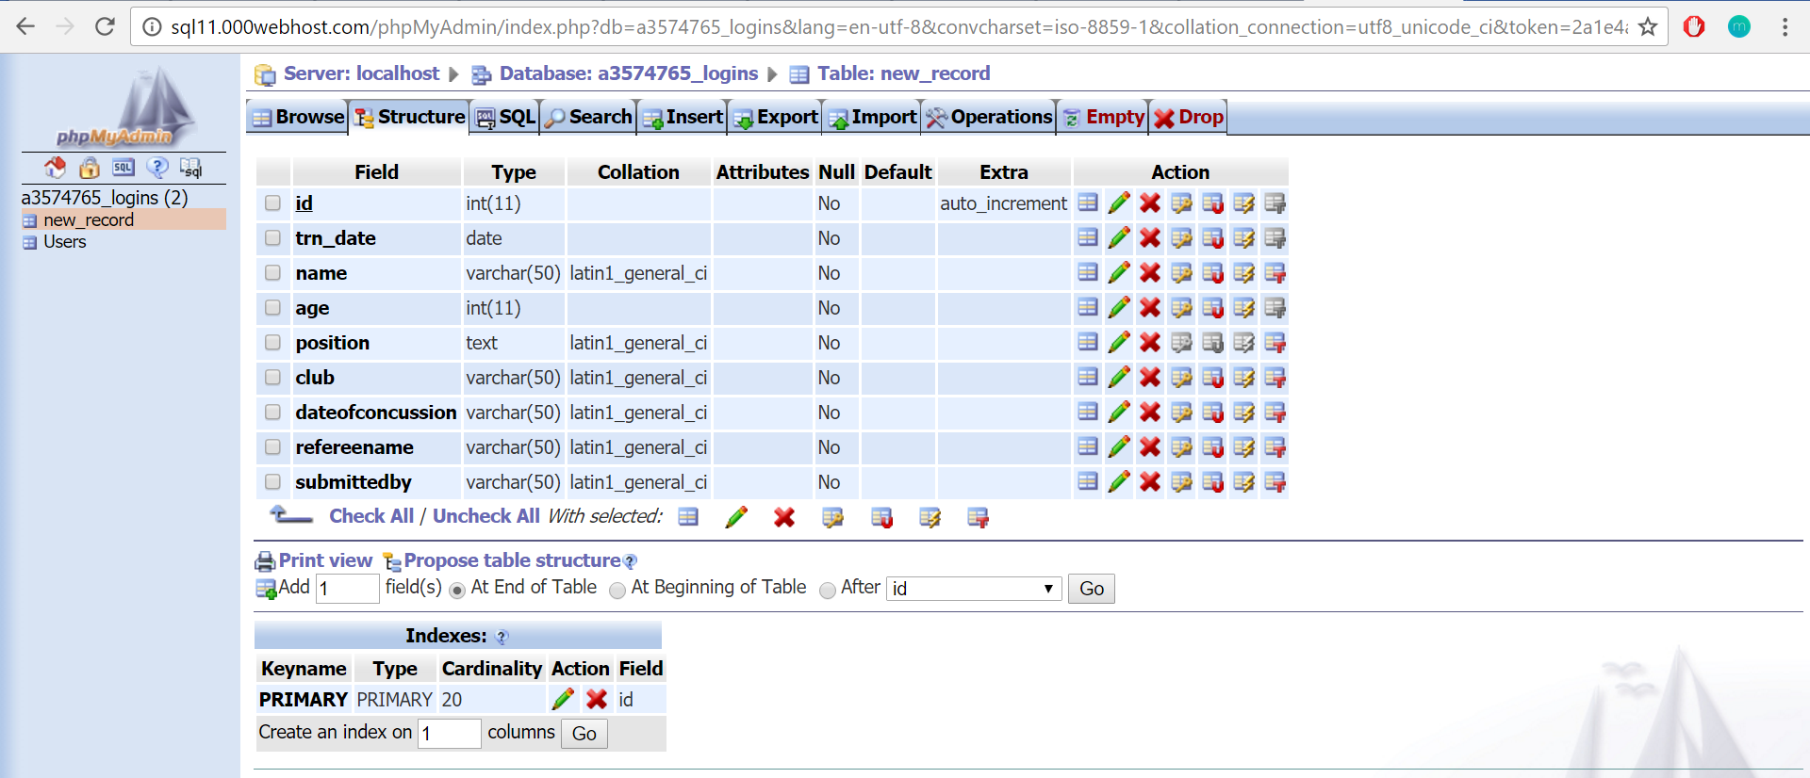

Figure : Screenshot of phpMyAdmin UI

### GitHub

GitHub is an online version control repository. The author used it in order to have a full backup of all the files relating to his project in the case of a system failure of his primary device. Keeping this full backup was good practice as a loss of data could mean months of work were for nothing. Instead of the standard Windows command line, the author used the Git Bash command line.

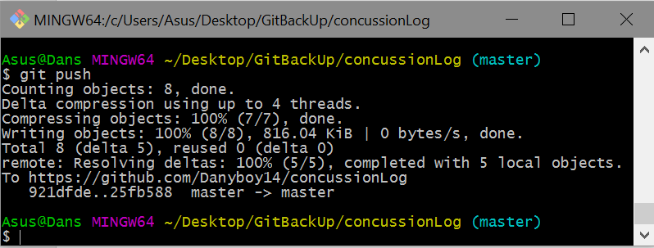

Figure : Git Bash

### Sublime Text

This text editor is what the developer use to write all his code. Unlike other text editors like Notepad, Sublime Text has several additional features which the developer found preferable. One of these was the split editing mode where he could work on two files side by side. This was especially helpful when working on the search and view files which are very similar in build. Along with this there was a distraction free mode which the author found essential. It gave him a full screen view of Sublime Text without any tabs along the bottom to get distracted by.

## Languages Used

### HTML

Hypertext Markup Language (HTML) is the cornerstone technology for building websites along with CSS and JavaScript. Browsers like Google Chrome and Firefox then build a webpage from the HTML file they receive. In this case, the HTML was embedded in the PHP pages.

### CSS

Cascading Style Sheets (CSS) describes how a markup language document is presented on screen. It is most often used with HTML but it can be applied to XML also.

### JavaScript

JavaScript is a dynamic programming language. It adds interactivity to the Concussion Log website. The developer used the jQuery library, the most widely used JavaScript library, to add the calendar pop-up when a user needed to input the date of a concussion.

### PHP

PHP is a server side scripting language. The developer used this to interact with his database. The PHP code is executed on the server which generates HTML code which is sent to the client. The developer had very little previous experience with this language before this project so the use of tutorials and the extremely extensive PHP documentation was essential.

### MySQL

MySQL is a relational database management system (RDBMS). The developer used phpMyAdmin to build his database as opposed to a command line and a script.

## Implementing the _______ Page(s)

### Landing

The landing page is the only page on the website written purely in HTML and CSS. There is no need for it to be written in PHP as there is no connection to the database. The developer wanted to have a number of guides for both parents, players and referees and a quick link for the documents that referees may need regarding concussions on the home page. He also wanted a way for users to register and login to his website to access the database. To do this he added <href> tags for both document links and links to other pages.

Once a user has logged in, they will be redirected to a page very similar to the original landing page, but which can only be viewed with a connection to the database. From here a user can go to the Dashboard where they can view records and insert more records.

### Registration & Login

The layout of the Registration and Login Pages are very similar. In both, there is a form to be completed by the user to move on to the next stage be it a successful registration or a login.

To successfully register, a user must fill in the username they want, their email address and a password. The registration.php makes sure that user’s email address is correct by making them input it twice. The strings are then compared and if they match, the form is submitted and the PHP adds them into the database via a $query or if they don’t match, the user receives an error message.



Figure : Email Address Match

To successfully login, a user must have an account registered already. Once the user submits their username and password to the system, the PHP queries the Users Table to make sure there is a user account with a matching username and password. If so, the user is logged in and if not, an error message is returned.



Figure : Login Error

### View Records & Search

This page is laid out as a table. All the data in the table is derived from the new_record Table in the database. All of it is input by the user apart from the eligibility of a player to play which is derived from today’s date and the players age. The Eligibility Function comes from the IRFU’s GRTP Protocol which states that the number of days that a player must take away from playing depends on the age of the player that has received a concussion.

The only user which can edit or delete a record is the user that submitted it. This makes sure that referees can only change their own submissions if they make a mistake. It is an essential function as it would be unfair if referees of other clubs could change players records that they know or players of opposition clubs to make sure that they can’t play. *Figure 14* gives the code which makes this simple but extremely effective function possible.

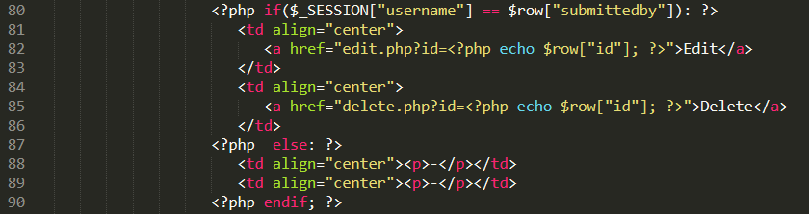

Figure : Edit/Delete

The search function on this page queries the database. Eventually when the database is well populated this will be a useful function for referees who are officiating a game and want to make sure that all the players from a certain team are eligible to play.

### Insert & Update Records

Again, the layout of these pages is extremely similar, the only difference being that the Update Records Page is already filled out with the row that is being edited. The PHP echoes the data from the database to the relevant parts of the form.

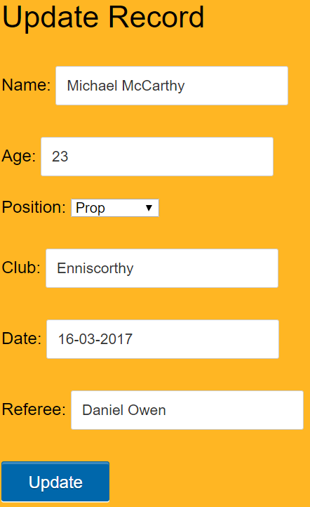

Figure : Update Record

The Date Section of the form uses the jQuery library from JavaScript. It adds a small bit of interaction to the page and makes sure that the user puts in the correct format of the date i.e. dd-mm-yyyy, which is the way it needs to be to be used in the Eligibility Function and that the date of concussion isn’t post-dated as it would be impossible to predict a concussion for a specific date in the future.

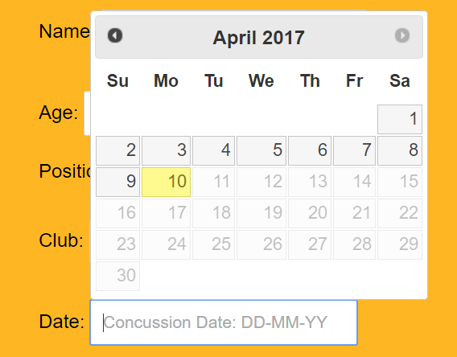

Figure : Datepicker

The jQuery library provides all the necessary documentation for the Datepicker Widget. It’s a highly customisable plugin which allows a developer to configure everything from format to language to restrict the selected date range which is what the developer did in the case of this system.

## 4.4 Chapter Conclusion

In Chapter 4, the author reviewed the different technologies he used when building this Concussion Log. He went through each of the technologies and languages used in depth. The developer also looked at how some of the pages on his website were implemented and the different functionality available to a user on each.

# Evaluation

To evaluate this project, the author felt it best to critique his ‘meeting of requirements’. This chapter will look at each one of them individually along with functional and non-functional requirements as independent sets. The chapter also looks at the small bit of testing undertaken by the developer.

## Testing

The testing of the system was broken down into unit and integration testing. It began with unit testing to make sure that each individual component worked on its own to validate that it did what it was supposed to do. These unit tests were carried out every time the developer changed a bit of the code. It also made debugging easier as only the most recently changed code needed to be debugged.

Once the separate units were tested and found to be working, the developer began piecing them together to make sure they worked in conjunction with each other. A similar method of testing was used when units were integrated but on a larger scale.

## The Grand Critique

The author was extremely happy with his ability to meet all the functional requirements set out in the beginning of the project. Each one of them came with their own challenges which were overcome after much research. The functional requirements acted as milestones for the developer. Completing each one brought him closer and closer to his end goal.

The first requirement to be met was to have a working user registration and login system. As the system went, this was a huge goal to achieve and a very necessary one. Without this, the website would have been a failure from the beginning. The developer achieved this with the help of tutorials and extensive PHP documentation available online.

Initially, MAMP was used to test the connections PHP was trying to make but a database hosted online was the next step. This was a crucial step towards having a fully live website. Once 000webhost.com was chosen, phpMyAdmin made building the database very simple. Making the connections between the developer’s PHP files was straightforward as the only thing that needed to be changed were the connection details in the db.php file. See *Figure 17* and *Figure 18* below.



Figure : Local Server Connect



Figure : 000webhost Server Connect

The next functional goal was to make sure a user could input data to the system and then view all the concussion submissions also. This was relatively uncomplicated as all that was needed to be built was a form and a way of getting the details inputted from the user’s screen to the database. Again, several tutorials were used along with the PHP documentation.

When it came to assessing if a player was eligible to play or not, the developer thought it essential that the system should output a value to a user. This would save the user from doing the calculations themselves. This took the developer quite a while to build as there was an issue regarding the PHP version which the server used. The developer was pleasantly surprised in his ability to overcome this obstacle.

To save the end user time when looking through the database, the author felt it necessary to implement a way by which a user could search the database for the information they needed. At present, there is a simple search feature to help with this but a more advanced one would be needed if the database was populated with thousands of records, which may be the case with a database used in a commercial setting. However, the search function that is implemented is extremely efficient, and returns the information as if one were viewing all of the records, but it only returns submissions which contain the queried string.

The non-functional requirements were split up into four groups as previously stated. These were: Usability, Reliability, Robustness, and Performance.

In terms of reliability, robustness, and performance, the website goes a long way to fulfilling these requirements. It is highly reliable as users can trust it and it runs with little or no downtime as the hosting server runs with no downtime. Concussion Log can handle very inexperienced users meaning it is scores very highly when it comes to robustness. The website itself ranks quite highly on the PageSpeed tool offered by Google. It scores 93/100 on the tool which rates the response times and performance of a website’s pages. With a load time of 565ms, the landing page is faster than 96% of websites tested by Pingdom, another website speed test.

Usability is down to each individual user. Some user’s may feel that more could be done to improve the ease of use of the website but the developer feels that it is remarkably quick to get from Point A to Point B and is happy with how easy he has made the website to use.

## Ethical Considerations

As this tool is open to all referees to use, it raises the question of how ethical is it in some regards. From a concussion point of view and a player welfare point of view, the tool helps referees make sure that a player who has a concussion can’t play. Individual teams and players may not like the fact that they won’t be able to play because of that but it does look after a player’s safety first and foremost.

When it comes to underage players, there may be certain considerations that should be taken in the reporting of concussions. First of all, the player’s coach should notify one of the player’s parents. Within the website there is a popup notification if the user is inserting the data for a player under the age of 20. The alert in *Figure 19* is just a reminder, nothing more.

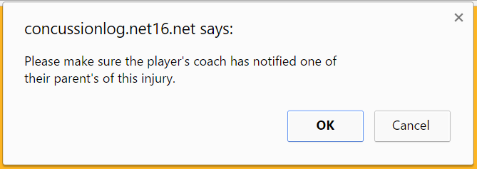

Figure : Popup Notification

The problem with an underage concussion would be inputting the details of an underage individual into a database which may raise some issues. Currently, all individuals who work with underage players are Garda vetted which is conducted on behalf of the IRFU and is in place to put the welfare of children playing the sport first (IRFU, 2016). This should be enough but it also may be necessary for parents to sign a waiver for the son/daughter to be included in the database.

If it is the case in the future where the database is used as part of a study, it may be required that a waiver of some sort is signed for all entries. In the case of underage players, a parent will sign it, but in the case of an adult player who has received a concussion there may be a problem as a concussed individual may be in no fit state to sign a waiver due to being knocked out or due to the loss of control of certain motor functions etc. In these terms, players would have to sign a waiver at the start of the season or at some stage after they have fully recovered before the details of their concussion can be put into the database.

## Chapter Conclusion

This chapter evaluates how the website meets the requirements gathered by the author at the beginning of the project. Each of the functional requirements are looked at individually and then the non-functional requirements are looked at in their four groups. This chapter also gives an overview of the testing the author used to make sure the different units worked on their own and when integrated. The author examines certain ethical implications which could arise with the use of this website with underage players and in the case of concussed adults who may not have full control of their motor functions. This may have a serious effect on the use of the website going forward.

# Conclusion

This concluding chapter will examine a number of problems the developer ran into over the course of this project. Moving on from any issues, it will look at what the author believes is in store for the website moving forward.

## Issues

Thankfully the author only ran into a number of issues with the overall project. There were a couple of issues regarding 000webhost and there was an issue with time management.

With respect to the hosting of the site, there was an issue regarding the version of PHP which ran on the servers. The most up to date version is PHP version 7.1.3 whereas the version which 000webhost runs is version 5.2 which has been out of date since late 2009. This became an issue when the developer had to find the difference between two dates. In newer versions of PHP, from 5.3 onwards, there is a function to find the difference between two DateTime objects.

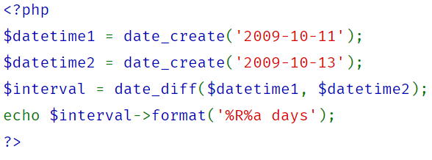

Figure : Date Difference Function Version 5.3+ (PHP, 2009)

Rather than write it this way, the author had to find another way of determining the difference between two dates. After much searching and learning about how time is formatted in PHP, the author stumbled upon a way of converting a string to time i.e. strtotime which converted a date to epoch time (the number of seconds which have elapsed since 00:00:00 (UTC), Thursday, 1 January 1970). From here the times were taken away from each other and the result was returned to a number of days.

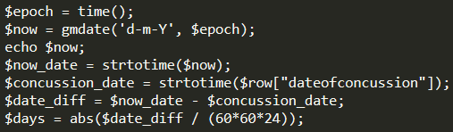

Figure : Concussion Log Date Difference

A second issue with 000webhost was the amount of time it took to update the Concussion Log site once the developer had uploaded a CSS file to the server. At times, it took a matter of hours or sometimes even days for the website to update. The author is putting this problem down to the fact that he was using a free web server to host his website as he couldn’t find a solution to his problem elsewhere.

Time management was a huge issue for the developer. This was the case especially during the Hillary Term when he was inundated with assignments for other modules. The developer should have envisaged this and in an ideal world would have made a Gantt chart so that most of the work could have been completed before the Christmas break This would also have helped him to structure his time more effectively in the Hillary Term.

## Future Work

At the beginning of the project, the developer set out five functional requirements he felt the system couldn’t work without. Each one of these was implemented, but along the way, the developer realised there was more that could be done to done make the system superior. To control scope creep, he recognised that these could only be dealt with after the completion of the project.

### Research Partner

From the research conducted and articles read by the author, it appears as though most of the information regarding concussions was coming from players. The self-reporting of concussions poses a huge question. Do all the players who receive a concussion report it? In the author’s view, they don’t. This is down to the fact that if they do report a concussion, they will not be able to play again for a minimum of three weeks per the IRFU’s GRTP Protocol. Along with this, players don’t want to be seen as weak amongst their teammates and won’t report a concussion because of this.

The developer would possibly like to partner with a researcher who is willing to gather data from referees with the use of Concussion Log. The only downside to getting information only from referees is that only concussions which happen in matches will be reported.

For a big enough sample to be obtained, it would be necessary to work in conjunction with the Leinster, Munster, Ulster, and Connacht provincial boards and their respective refereeing associations.

If the information put into the database is to be used for research purposes, it may also be necessary for a waiver to be signed by a concussed player. However, this may lead to certain issues. See the section on ethical considerations for more information.

### Statistical Element

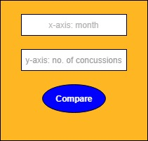A function would need to be implemented where an individual could query the database and receive the data such as which position is most prone to injury or if there are possibly certain times of the year where the occurrence of concussions rise. Below is a hypothetical UI of what the input and output of such a feature might look like. Unfortunately, the developer didn’t have time during the project to implement this function.

Figure 22: Statistical Element Mock-up

Figure : Statistical Element Mock-up

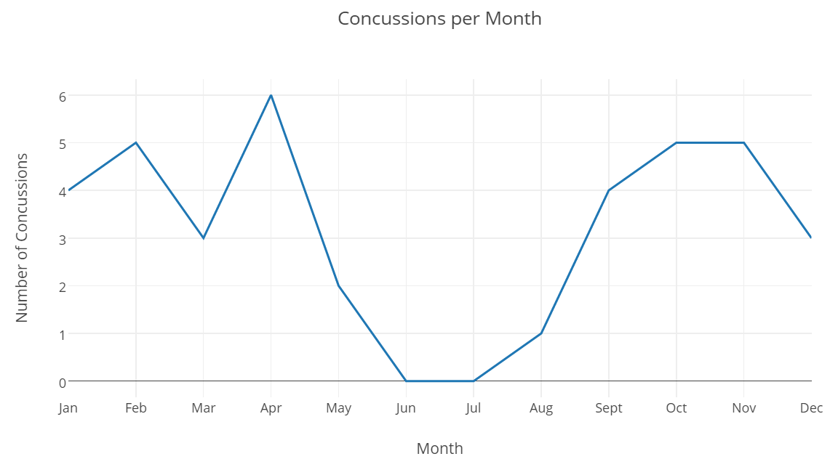

Figure : Number of Concussions per Month

### Increased Search Functionality

A researcher and referees will need a more advanced search function in order to search for more specific terms within the database. A possible way of doing this would be to query the database twice and return the search results. This will be the case if the database becomes much more heavily populated in the future.

A simple solution to this might be to assign a player’s registration number (which is used at an underage level to assign a certain age grade to a player) to their input. In this way, a referee could search for this number as opposed to a more complicated search of a player’s name, club and age.

### System Usability Scale (SUS)

To identify what referee’s think of the current iteration of the system the author would need to find the System Usability Scale (SUS), the industry standard for measuring usability (Brooke, 1996). An SUS is made up of 10 questions with five responses each. The great thing about an SUS is that it is easy to administer and can effectively tell the difference between a usable and unusable system. The author feels that he wouldn’t need to seek ethical approval again for this as he has already been approved to conduct research on this subgroup.

## Conclusion

This report has described exactly what it takes to make an idea a reality. It outlines the processes of researching, designing, requirement gathering, implementing and testing to name but a few. At the professional level of the game records are kept and the players are monitored constantly to make sure their condition doesn’t deteriorate in the case of a concussion. This tool aims to change the way concussions are dealt with after the fact in the domestic game, where there is very little record keeping. It sets out to make sure that referees know exactly if a certain individual is eligible to play a game or not and this could save someone from receiving another concussive blow in a matter of weeks which could be detrimental to their health.

The author feels that there is much still to do before Concussion Log can be used as part of a research project, he still needs to add a statistical element to the project and implement a more advanced search function before he feels he could find a researcher who would use Concussion Log as part of a study. When the website finally arrives at this stage, the developer would like to see where the website sits on the System Usability Scale.

The author is pleased with his ability to bring a problem of this scale from an idea written on a scrap of paper to its current iteration, overcoming several obstacles along the way. It is a practical solution to a serious problem and may in time prevent someone from being seriously hurt.

Even though there are certain limitations within the system at present, the author believes that there is a serious problem regarding concussions at present and what is presented here is a system which should definitely be looked at by the IRFU.

# Appendices

Appendix 1: Mockup -v- Reality

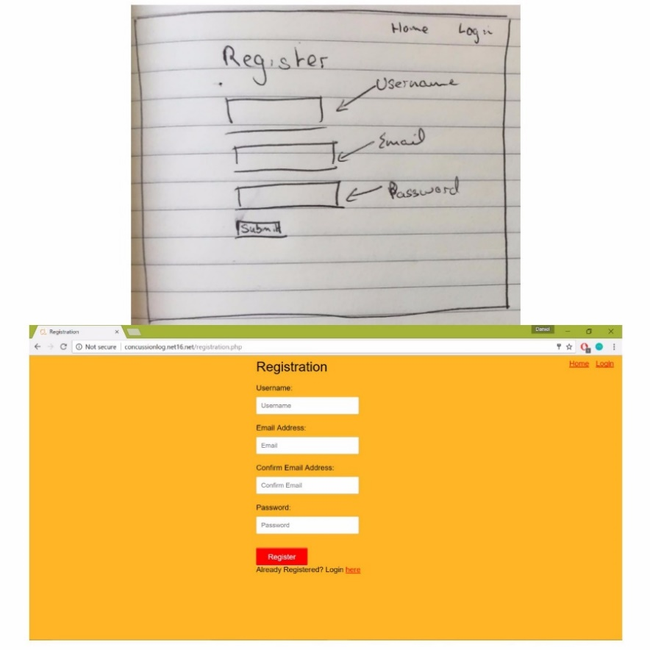

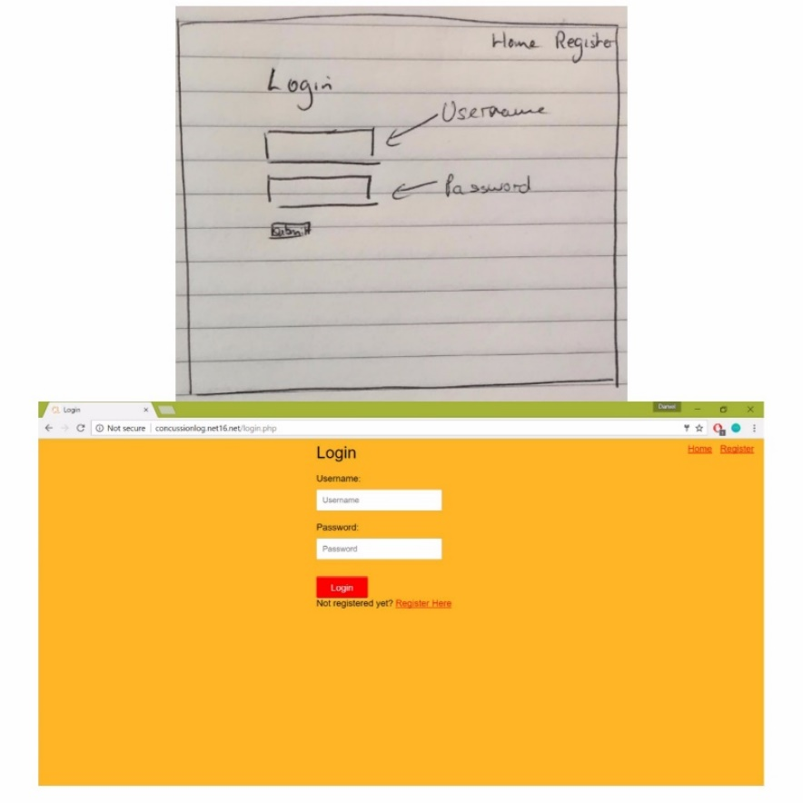

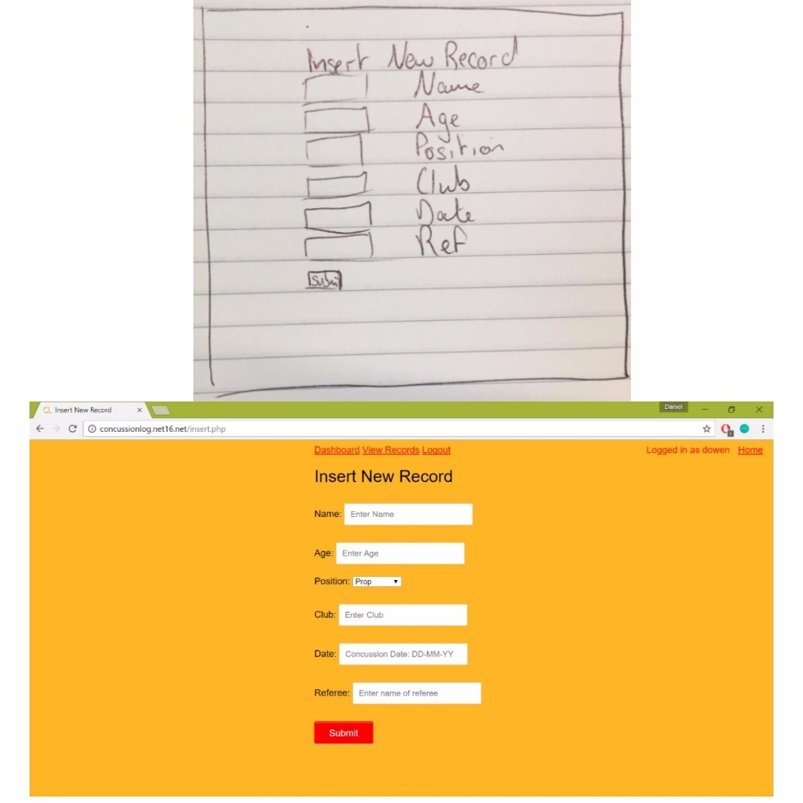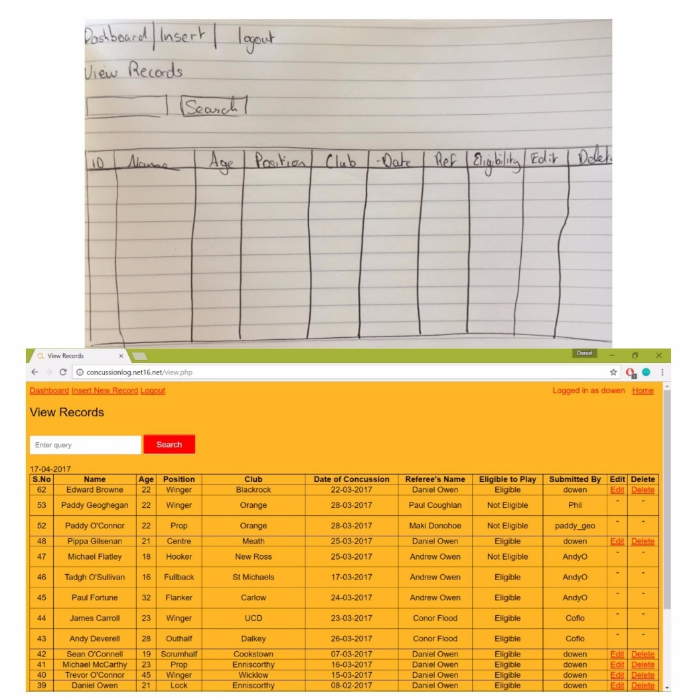

Relational Schema

Class Diagram of Database:

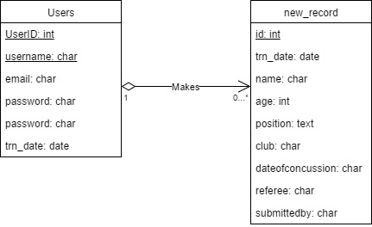

Relational Schema:

# Ethics Approval Documents

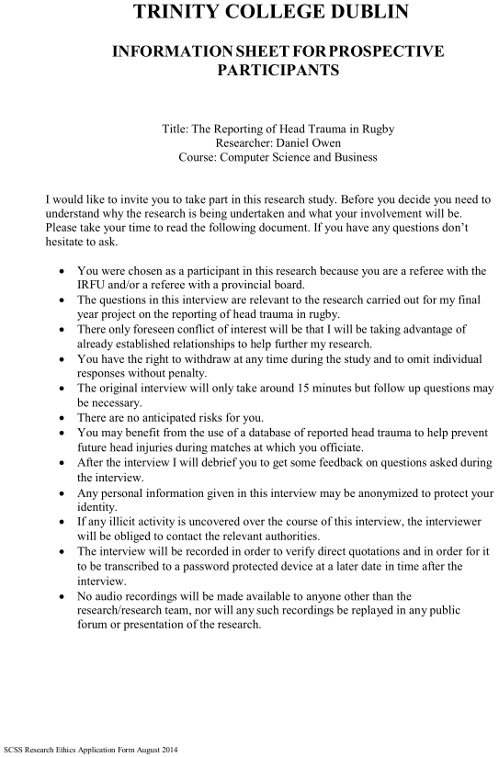

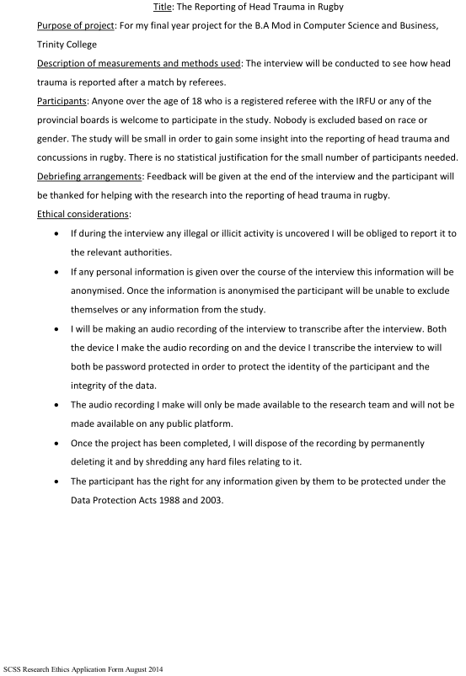

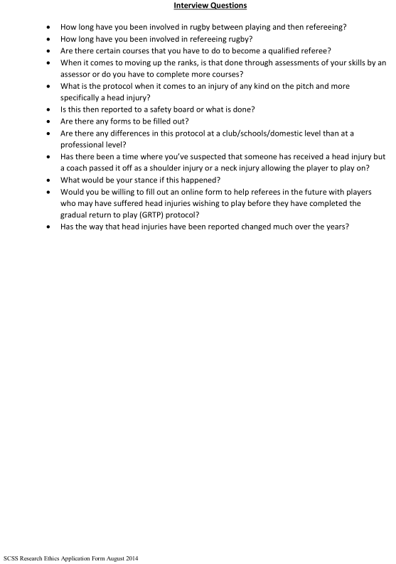

# References

American Association of Neurological Surgeons, 2017. *Concussion.* [Online]   
Available at: http://www.aans.org/patient%20information/conditions%20and%20treatments/concussion.aspx  
[Accessed 05 April 2017].

Baker, J. F., Devitt, B. M., Green, J. & McCarthy, C., 2012. Concussion among under 20 rugby union players in Ireland: incidence, attitudes and knowledge. *Irish Journal of Medical Science,* 182(1), p. 121.

Brainline.org, 2012. *What You Need to Know: Symptoms of Concussion.* [Online]   
Available at: http://www.brainline.org/content/2012/06/what-you-need-to-know-symptoms-of-concussion.html  
[Accessed 6 April 2017].

Brooke, J., 1996. SUS - A Quick and Dirty Usability Scale. *Usability Evaluation in Industry,* 189(194), pp. 4-7.

England Rugby, 2016. *Concussion in Rugby.* [Online]   
Available at: http://www.englandrugby.com/mm/Document/General/General/01/31/43/26/2Concussioninrugby_English.pdf  
[Accessed 15 April 2017].

Glennon, M., 2017. *'They've lost total control of concussion' - O'Driscoll hits out at World Rugby.* [Online]   
Available at: http://www.rte.ie/sport/rugby/2017/0115/845159-george-north-concussion/  
[Accessed 12 April 2017].

IRFU, 2013. *A Guide to Concussion in Rugby.* [Online]   
Available at: http://www.irishrugby.ie/downloads/IRFU-Guide-to-Concussion.pdf  
[Accessed 11 November 2016].

IRFU, 2016. *IRFU Vetting Policy.* [Online]   
Available at: http://www.irishrugby.ie/downloads/IrishRugbyvettingpolicy2016.pdf  
[Accessed 14 April 2017].

Mayer, A. R., Toulouse, T., Ling, J. M. & Klimaj, S., 2013. A prospective study of gray matter abnormalities in mild traumatic brain injury. *Neurology,* 81(24), pp. 2121-2127.

Mooney, B. L., 2013. *New CTE Study Categorizes Stages of Degenerative Brain Disease in Veterans, Athletes.* [Online]   
Available at: http://www.usmedicine.com/agencies/department-of-veterans-affairs/new-cte-study-categorizes-stages-of-degenerative-brain-disease-in-veterans-athletes/  
[Accessed 12 March 2017].

Omalu, B. I. et al., 2005. Chronic Traumatic Encephalopathy in a National Football League Player. *Neurosurgery,* 57(1), pp. 128-134.

Patricios, J. et al., 2017. What are the critical elements of sideline screening that can be used to establish the diagnosis of concussion? A systematic review. *British Journal of Sports Medicine,* Volume 0, pp. 1-9.

PHP, 2009. *DateTimeInterface.* [Online]   
Available at: http://php.net/manual/en/datetime.diff.php  
[Accessed 15 March 2017].

Stewart, W. et al., 2016. Chronic traumatic encephalopathy: a potential late and under recognized consequence of rugby union?. *Quarterly Journal of Medicine,* 109(1), pp. 11-15.

Verganti, R., 2008. Design, Meanings, and Radical Innovation: A Metamodel and a Research Agenda. *Product Innovation Management,* 25(5), pp. 436-456.

W3C, 2008. *Web Content Accessibility Guidelines (WCAG) 2.0.* [Online]   
Available at: https://www.w3.org/TR/WCAG20/  
[Accessed 10 April 2017].

Whooley, D., 2017. *Former Ireland team doctor 'concerned' by HIA protocols.* [Online]   
Available at: https://www.rte.ie/sport/rugby/2017/0116/845219-beirne-hia/  
[Accessed 12 April 2017].

World Rugby, 2017. *Laws of the Game Rugby Union.* [Online]   
Available at: http://laws.worldrugby.org/?law=3.10&language=EN  
[Accessed 24 March 2017].

# Tutorials Used

Codecadamy JavaScript Tutorial: <https://www.codecademy.com/learn/javascript>

Codecadamy HTML/CSS Tutorial: <https://www.codecademy.com/learn/learn-html-css>

User registration PHP and MySQL 1: <https://www.youtube.com/watch?v=lGYixKGiY7Y>

User Registration & Login Script in PHP and MySQLi: <http://www.allphptricks.com/simple-user-registration-login-script-in-php-and-mysqli/>

Insert, View, Edit and Delete Record from Database Using PHP and MySQLi: <http://www.allphptricks.com/insert-view-edit-and-delete-record-from-database-using-php-and-mysqli/>

W3schools PHP Insert Data in MySQL: <https://www.w3schools.com/php/php_mysql_insert.asp>

W3schools PHP connect to MySQL: <https://www.w3schools.com/php/php_mysql_connect.asp>

W3schools PHP 5 Date/Time Functions: <https://www.w3schools.com/php/php_ref_date.asp>

W3schools PHP 5 if…else…elseif Statements: <https://www.w3schools.com/php/php_if_else.asp>

Simple Search Using PP and MySQL: <https://owlcation.com/stem/Simple-search-PHP-MySQL>

Tutorial Republic PHP Form Handling: <http://www.tutorialrepublic.com/php-tutorial/php-form-handling.php>

Tutorial Republic PHP GET and POST: <http://www.tutorialrepublic.com/php-tutorial/php-get-and-post.php>

Tutorial Republic PHP Date and Time: <http://www.tutorialrepublic.com/php-tutorial/php-date-and-time.php>

Tutorial Republic PHP MySQL INSERT Query: <http://www.tutorialrepublic.com/php-tutorial/php-mysql-insert-query.php>

Tutorial Republic PHP 5 Date and Time Functions: <http://www.tutorialrepublic.com/php-reference/php-date-and-time-functions.php>

Tutorial Republic PHP MySQL DELETE Query: <http://www.tutorialrepublic.com/php-tutorial/php-mysql-delete-query.php>

jQuery Datepicker: <http://jqueryui.com/datepicker/>